

|  |
| --- |
| **Provocative Magazine** |
| An E-magazine providing reader’s fact checked information about current events and news. |
| CIS 3010-14  September 28, 2018  Erick Corona-Ramirez  Miguel Guzman Valle  Stephanie Gonzalez  Xue Feng  Yijing Cheng |
|  |





After the previous company meeting we have come up with a business proposal to be centered as an online magazine. This magazine will focus on fact checking the information given to us by reporters or journalist. Using the data that we collect will allow us to tailor them towards the correct demographic more effectively. However, since fact checking and transparency with our readers is a high priority; sponsored content from advertisers in the e-magazine will always be disclosed in an easily recognized format. In order to help create value with or e-magazine we plan on offering a subscription service that will get rid of all advertising except special sponsored article piece in addition to the free. This will not only inform our readers about current events, news, and tech but also, keeping the overwhelming amount of information as low as possible giving just the overview and providing the facts and important parts to the public. The targeted audience is centered on young adult from ages 20 – 30 years old but the content would be easier to absorb which will help appeal to younger or older audience. Not only will this magazine be available for our readers to view online as well as on a mobile application.

When developing this magazine, we will do everything on our own pace to help build the success of our magazine. For starters it would be in to build trust, as a fully build magazine without public notice is bound to fail unless there are connections to go around. We will use technology like: laptop, desktop, and cellphone with cellular data/ Wi-Fi to help readers access the magazine. The usage of NAS, backup drive, or cloud storage with all the data collected to have an archive of all that has been created would be a good add on but not completely necessary at the beginning. We will first start off with a blog, social media like Facebook or Instagram, and help promote our magazine. By creating different post in different forums and networks with the name of the magazine or authors that will work on it to attract the attention of the target audience. All while doing this we will have a designated manager in charge of editing and reviewing to make sure we are providing the highest writing possible. Also, by keeping a tab on similar communities and keeping up to date with their userbase. This will provide information on how this similar site will fare as well. These communities are not only great places to start a networking and building a small follower count but also, discovering new journalist who will want to write for our magazine only if they follow the site’s guide lines.

After all that, gaining trust and attention would be easier to diverge everything to the online magazine that will be created. Buying a website space would be the most affordable than a VPS or a standalone. Designing the website to be user friendly and easy to use, so readers have easy access to all tools and things that will be implemented. We will also have someone in charge of the website in case any attention needed to the segmentation of the website for the magazine, the reasonable structure, the optimization of the website, and the affinity of the interface. By doing so we can ensure that the website is uploaded to the server and related settings are bound properly, also making sure that a routinely maintenance is carried out properly as well. By having our magazine available in the app store for android and ios this will provide easier access to our magazine to our readers and catch the attention of those who have yet to read our magazine. This will allow the magazine to grow and allow it to get some revenue while on it.

In order to create revenue, the magazine has to grow to at least certain degree. As there no easy way to draw in companies to sponsor a newly build magazine. We believe that e-magazines can bring a lot of benefits for example, letting the author and the reader generate trust, let more people become experts in the field, and keep the author and the reader in constant contact. Our company can use the contact information for subscribers to sell products. When someone subscribes to an e-magazine, they also tells us their email address. In addition to sending e-magazines to their mailbox, you can also inform them about the sales of some products. This is more effective than sending the information to users who don't subscribe to the magazine at all. Since cellphones, are the most convenient and portable devices, audiences would probably spend more time using their phones obtaining more information. We could mainly focus on creating our app with the easiest procedure to interact with audiences. Many useful features, such as translation, notes, highlight, etc, could be added into the app, also it has the ability to record reading history and time spent on it for audiences. A good app would increase customer loyalty which is very important to our business. Audiences’ personal information could be collected through the process of user register. The app will provide them the option of connecting Facebook account or twitter account to finish registering. When those accounts are connected to the app, we could collect basic background information from audiences. The reading history also tells us what kind of information is being consumed by audiences in the different age groups Furthermore, we also plan on keeping data on what users read and look at when on the app. This will allow us to see kind advertising is more effect as well as what topics to prioritize which will lead to an increase in paid subscripts to the e-magazine. We plan on implementing affiliate links to the site with items that are mention in the publication allowing the business to get a small revenue out of it. While also having a one-time donation page to help support the magazine stay as transparent as possible. In addition, our magazine needs to increase the impression of authority to the population so that target demographic will trust our information, and keep adapting our magazine as a great resource to improve their academic study or personal lives. We can also market our magazine through advertising, academic paper, etc. The other way is to collaborate with respected institutions like schools by providing reliable facts with lower prices compared to online academic databases.

**Porter’s Five Force Model of Competition**

|  |  |
| --- | --- |
| Competitive Forces/ Forces strength | Analysis/Reason |
| Threat of Entry of New Competitors:  Low to medium | Entry to the business is somewhat difficult as new entrants have to gain trust of the public before they gain notoriety of companies that would like to work with them.  The ones that enters would probably go for different type of topics or niche to make their magazine different. |
| Bargaining Power of Buyers:  Medium to high | There is also multiple type of magazines.  Buyers can search for what they want in others magazine.  But also, since our magazine will be constructed in a more detail and fact check base, in which information would be more precise it would hold its advantage there. The goal of our business is to gradually popularize our magazine into community through social media such as Instagram, Facebook, and use email connection and convenient app to build customer royalty. If we go step by step, buyer may not have too much bargaining power because they have been already accustomed to get reliable information from our magazine. |
| Bargaining Power of Suppliers:  Low | The Suppliers are the developers for the magazine as well as the writers. However, their bargaining power is low since there’s thousands of college graduates that can easily replace any one of the developers or writers. |
| Threat of Substitute Products:  Low to Medium | There is already different type of magazine out there, plus those that want to enter the market.  Not many are center in only facts or detail information which led to a big diversity of information and allow ours to get more attention. |
| Industry Competitors:  High | There are large number of firms in the industry. |

In order to be profitable our key strategy will be to differentiate ourselves from the competition. This is where we will invest heavily in marketing our fact checking and transparency. In hopes that this will give us a competitive advantage over other online publications that create a need to be a subscriber to our online magazine.

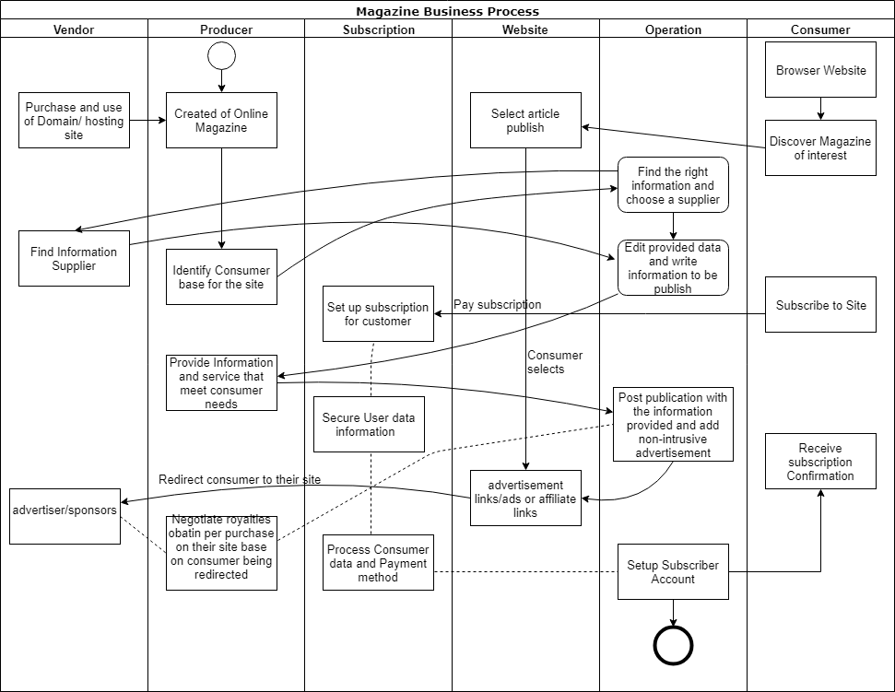Its starts off with the customer browsing the web or the app and stumbling upon on of our articles that catches their interest. After that they may decide to click on an advertisement and learn more about that product or subscribe to our magazine. Upon subscription the user data gets collected and processed to create the user account which will allow them to receive full feature access to the site. After that the user receives a confirmation email and from there they will receive their monthly subscription.